User Acceptance Testing (UAT) Template
Project Title | DarshanEase: A Smart Temple Darshan Booking System Using MERN Stack
Team ID | ALITS-CSD-2026-DarshanEase
Team Members | Salapala Tharun Kumar Reddy (Team Leader); A. Goutham; M. Siva Prasad; M. Akhila; K. Hemalatha
College | Anantha Lakshmi Institute of Technology and Sciences (ALITS)
Academic Year | 2026

Project Overview
Project Name: DarshanEase: A Smart Temple Darshan Booking System Using MERN Stack
Project Description: A full-stack MERN web application enabling devotees to register, browse temples, book darshan slots, manage bookings, and plan travel, with an admin dashboard for temple and booking management.
Project Version: 1.0
Testing Period: UAT conducted prior to final submission of the project.
Testing Scope
- User registration, login, and session handling
- Temple listing, temple details, and search
- Darshan slot booking and confirmation
- Booking history view and cancellation
- Journey planner search results
- Admin dashboard: temple/slot management and booking management
Testing Environment
URL/Location: Local development server (http://localhost:5173 frontend, http://localhost:5000 backend API)
Credentials: Test devotee and admin accounts created for UAT

Evidence from test execution
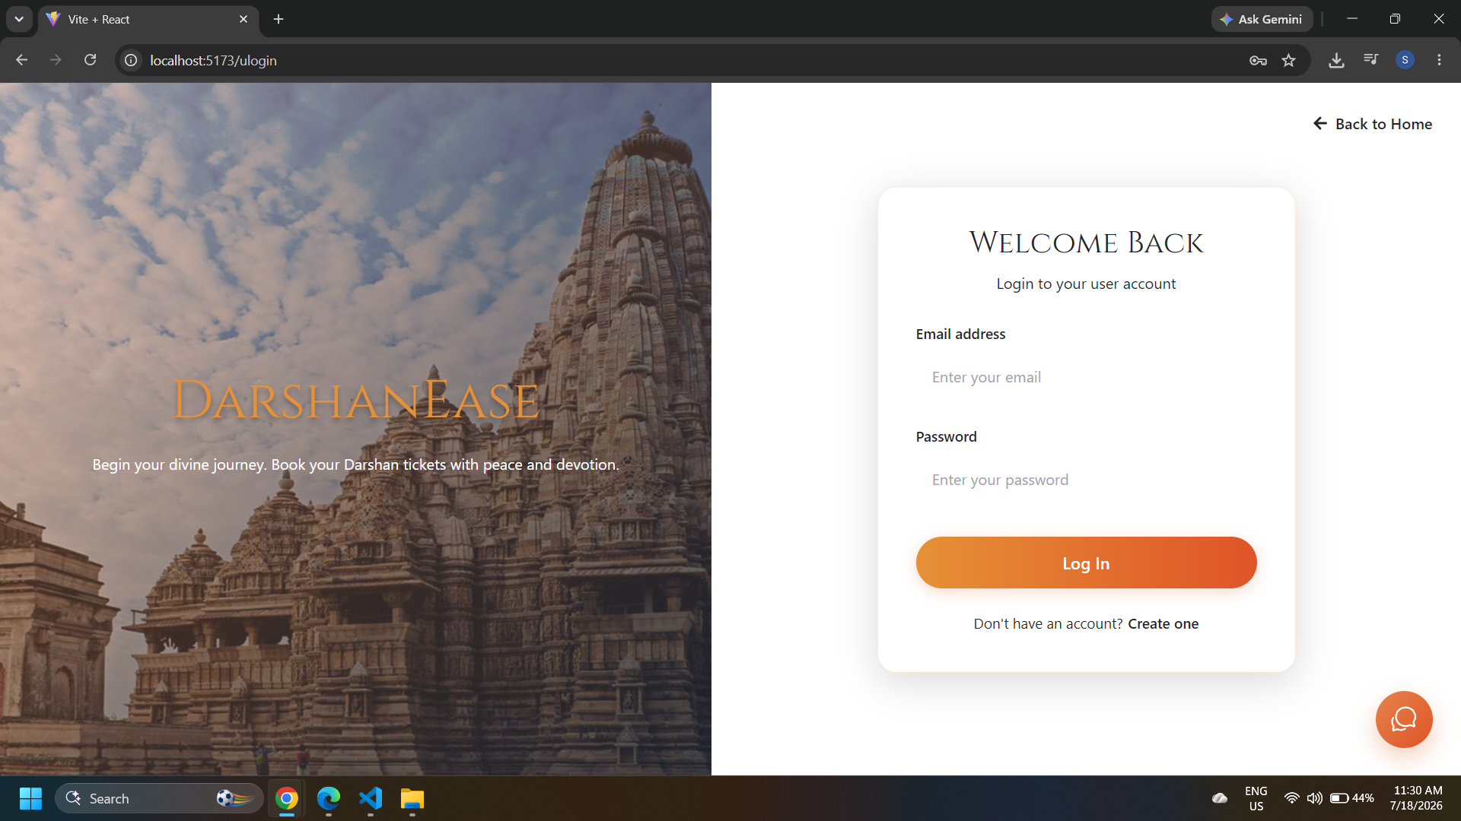
Figure: TC-003 — Login page used for authentication testing
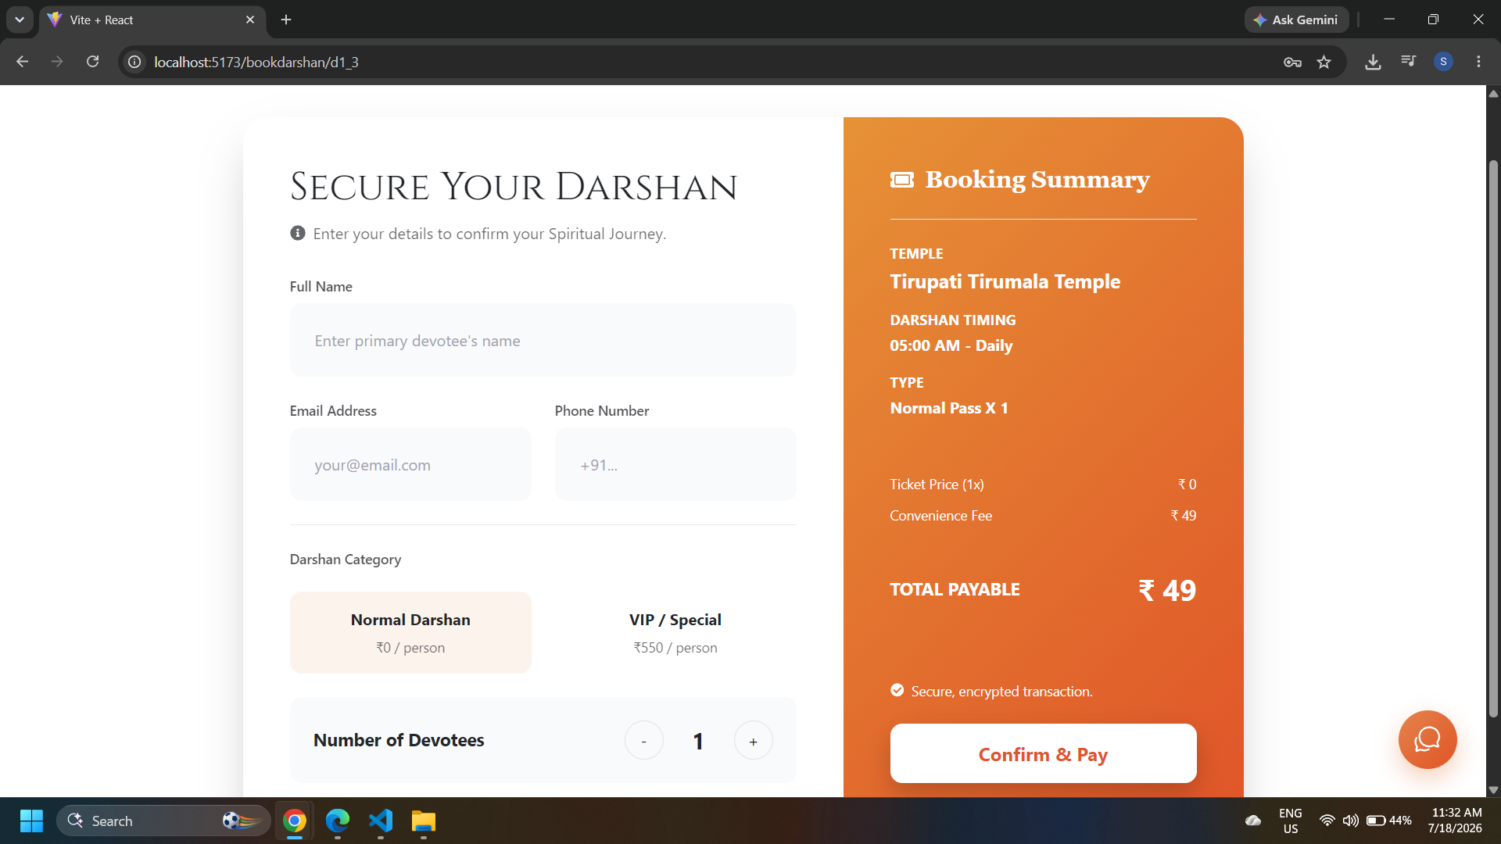
Figure: TC-005/TC-006 — Darshan booking form used for slot booking tests
Test Cases
Test Case ID | Test Scenario | Test Steps | Expected Result | Actual Result | Pass/Fail
TC-001 | New user registration | 1. Open register page 2. Enter valid details 3. Submit | Account created, redirected to login | As expected | Pass
TC-002 | Duplicate email registration | 1. Register with an already-used email | Error message shown, registration blocked | As expected | Pass
TC-003 | User login | 1. Enter valid email/password 2. Submit | Redirected to dashboard with JWT session | As expected | Pass
TC-004 | Browse temple list | 1. Navigate to temples page | List of temples with name and location displayed | As expected | Pass
TC-005 | Book darshan slot | 1. Select temple 2. Choose date/slot 3. Confirm booking | Booking confirmed with unique booking ID | As expected | Pass
TC-006 | Book a fully occupied slot | 1. Select a slot at capacity 2. Attempt booking | System rejects booking, shows alternative slots | As expected | Pass
TC-007 | View booking history | 1. Navigate to booking history page | All past and upcoming bookings listed | As expected | Pass
TC-008 | Admin manages temple data | 1. Log in as admin 2. Add/update a temple | Changes reflected immediately in temple listing | As expected | Pass

